Automatic recognition and analysis system of asphalt pavement cracks using interleaved low-rank group convolution hybrid deep network and SegNet fusing dense condition random field

Gang Li 1,*, Qiangwei Liu 1,**, Wei Ren2, Wenting Qiao 2,3, Biao Ma1 and Jian Wan1

(1 School of Electronic and Control Engineering, Chang’an University, Xi’an 710064, Shaanxi, China; 2 School of highway, Chang’an University, Xi’an 710064, Shaanxi, China; 3 Inner Mongolia Transport Construction Engineering Quality Supervision Bureau, Hohhot, 010020, Inner Mongolia, China)

*Correspondence: [15229296166@chd.edu.cn (G.L.)](mailto:15229296166@chd.edu.cn%20(G.L.));

** Correspondence: [lqw18153972588@163.com](mailto:lqw18153972588@163.com) (QW.L.).

**Abstract**: Pavement crack detection is a key task to ensure driving safety. Manual crack detection is subjective and inefficient. Therefore, it is very important to develop an automatic crack recognition system. However, asphalt pavement crack detection from images is a challenging problem due to the interference of complex noises. Meanwhile, although deep learning-based methods have recently made great progress in crack classification and recognition, there are still difficulties, such as large parameters and low detection efficiency. For this purpose, we develop a novel crack recognition and analysis system. Firstly, crack images are cut by using the overlapping sliding window to establish crack datasets. Then a crack classification algorithm based on interleaved low-rank group convolution hybrid deep network (ILGCHDN) is proposed to recognize cracks and non-cracks. Next, we propose a crack image binarization architecture called SegNet-DCRF, which fuses the SegNet and the dense condition random field (DCRF). Finally, calculate the unidirectional crack width and the web crack area. Moreover, an interactive crack detection software is developed to further display various information on results. Experimental results show that our model is superior to other state-of-the-art algorithms in terms of accuracy, parameters, speed, and anti-interference ability. Also, for cracks with width of 3 mm or more, the relative error is less than 0.02, which better achieves the actual engineering requirements. Besides, the area of web cracks is calculated to comprehensively evaluate the pavement damage level.

**Keywords：**Crack classification, low-rank group convolution, binarization, SegNet-DCRF, mean crack width, web crack area, asphalt pavement

1. **Introduction**

1.1 Motivation

Maintaining pavements in good condition is a significant task for national and local transportation maintenance departments. Due to long-term weathering, rain, snow, stress and other factors, the surface and internal structure of asphalt pavements appear different cracks. These cracks directly reflect the health of asphalt highway structures[1]. Therefore, timely and accurate crack detection is very important for highway maintenance and accident prevention.

The manual detection method completely depends on the knowledge and experience of the engineering inspector, so it lacks certain objectivity in quantitative analysis. Besides, there are other methods for crack detection by using traditional crack detection methods, such as edge detection[2,3], or image processing techniques[4,5]. Although these methods have partially replaced some labor, these methods are sensitive to various noises and obstacles on the pavement. Also, some deep learning-based methods have recently made great progress in crack classification and recognition. However, there are still difficulties, such as large parameters, low detection efficiency, and poor anti-interference ability.

In response to these problems, it is necessary to optimize existing detection algorithms or develop more effective crack detection algorithms. Moreover, the most existing crack datasets with good image quality, a clear target and a single background, which leads to the poor generalization ability of the crack detection algorithm developed on this basis. Also, most pixel-level crack detection algorithms based on deep learning are difficult to eliminate the effect of pseudo cracks. Based on the above analysis, this paper develops an automatic recognition and analysis system of asphalt pavement cracks. This system first uses the ILGCHDN model to recognize cracks and non-cracks, and then uses the SegNet-DCRF model to binarize crack images. This progress can eliminate the effect of pseudo cracks and improve the efficiency of the actual project. Meanwhile, as shown in Figure 1, we establish a pavement crack dataset in a real environment, which contains plant interference, water stains, oil stains, parking line, rutting mark, manhole cover, shadow, scratches, rough background, etc. And it also can provide a technical support for highway maintenance departments.

 

(a) Non-crack images (b) Crack images

**Figure 1.** Asphalt pavement crack datasets

1.2 Related work

A. Traditional crack detection methods

In this study, we refer to crack detection methods based on non-deep learning techniques as traditional crack detection methods. In recent years, some image processing techniques (IPTs) and machine learning have been used to detect cracks in civil infrastructure, and have replaced manual field detection in some cases[6]. The traditional crack detection framework devises various gradient features for each image pixel, and then the binary classifier is used to determine whether the image pixel contains cracks[7]. Hoang et al. proposed a pavement crack classification algorithm based on image processing and machine learning, which uses the support vector machine (SVM) to classify whether each image block contains cracks or not, but this method is not effective for complex cracks[8]. M. Salman et al. presented a road crack detection method based on the Gabor filter, the Gabor function was used to analyze crack images and detected cracks, but this method is not effective in detecting cracks with complex textures[9]. Qin et al. presented an automatic crack detection method from pavement images. In this method, a set of seeds were extracted from the crack probability map, and these seeds were represented by a graph model. The minimum spanning tree was derived from the graph, and the edge of the tree was recursively pruned to identify the ideal cracks[10]. H. Oliveira et al. proposed a fully integrated automatic crack detection and characterization system for flexible pavement surfaces, which did not require manually marked samples. Meanwhile, this system was proposed to minimize human subjectivity generated by the traditional visual investigation. The system divided nonoverlapping image blocks into either containing crack pixels or not, thereby achieving the purpose of crack detection[11]. These mentioned methods encode local features of cracks, but lack a global perspective of cracks. For this reason, to detect cracks from a global perspective, Amhaz et al. accomplished crack detection by considering photometric and geometric characteristics of crack images. And then, a two-stage method was proposed for crack detection: first select endpoint at a local scale, second select minimal paths at a global scale. This method partially eliminates noises and enhanced continuity of detected cracks, but this method ignores the interdependence among cracks, the detection performance is not ideal when dealing with cracks with uneven strength or complex topology[12].

Although traditional crack detection algorithms have achieved good results compared to the manual crack detection, when dealing with the influence of complex noise interference and complex background, the detection accuracy and efficiency are not high. The failures of these algorithms can be attributed to the lack of reliable feature representation and the neglect of the interdependency among cracks. Besides, one of the biggest challenges are that the features are usually manually designed for some crack detection tasks, and they may not work properly if some conditions are changed. Therefore, it is particularly important to explore an effective crack detection algorithm.

B. Deep learning-based crack detection methods

Since 2012, deep learning-based algorithms have made rapid progress. More and more deep learning-based algorithms have been widely used in the asphalt pavement crack detection, such as image classification[13,14], object detection[15,16], and semantic segmentation[17,18]. Cha et al. proposed a crack detection algorithm using a convolutional neural network (CNN), which used the CNN model to construct a classifier for detecting pavement cracks from images. This algorithm used two sliding windows to scan the image to achieve the extraction of crack regions. However, due to the nature of photographic images, the CNN cannot detect crack internal features[19]. Next, Cha et al. improved the sliding window technology in the CNN and proposed a faster region-based convolutional neural network (Faster R-CNN)-based structural visual inspection method, which used the flexible bounding boxes to scan image to detect cracks in various cracks. However, the algorithm can only detect the position of cracks, and cannot extract cracks[20]. Chen et al. improved the traditional convolutional neural network and proposed a crack detection algorithm using convolutional neural network and Naive Bayes (NB-CNN) for data fusion. This method effectively discards the false detection, and the detection effect is better than the CNN. However, the NB-CNN integrates Naive Bayes, which makes the model more complicated and increases the model parameters[21]. Zhao et al. proposed a crack detection method based on the multi-input convolutional neural network (MI-CNN). This method first used convolution kernels of different sizes to extract image features from different dimensions under different input, so as to make full use of the original image information. And then, the feature extracted from each input is adaptively fused. Finally, the softmax function is used to complete the classification of cracks. Although the detection accuracy is improved in this way, the model parameters and the amount of calculation are relatively increased [22].

The crack detection algorithms mentioned above can only classify cracks, and cannot accurately extract the location of cracks. For this reason, the researchers have continuously improved the convolutional neural network and proposed many pixel- level crack detection algorithms. In[23], the fully convolutional network (FCN) was used to achieve the pixel-level crack detection, which can achieve an end-to-end prediction. However, for thin cracks, intersections, and cracks close to the image boundary, the detection effect is not good. Moreover, the real-time processing capacity still needs to be improved. In[24], the U-Net was used to detect the concrete crack, which can identify crack locations from input images under various conditions with high effectiveness. However, due to the limitation of the number of datasets, the robustness of the model needs to be improved. Fan et al. considered an encoder-decoder architecture with hierarchical feature learning and dilated convolution, and proposed a U-Hierarchical Dilated Network (U-HDN) to perform crack detection. The proposed U-HDN method can fuse different context sizes and different levels of feature maps. Although the U-HDN can obtain a satisfactory performance than the U-Net, the structure of U-HDN is complex, including redundant feature maps, which has a large amount of calculation and low efficiency[25]. In[26], this work proposed a framework based on the convolutional neural network, which implements crack detection through convolution feature fusion and pixel-level classification. In[27,28], the SegNet[29] has been successfully applied to crack detection, but it causes information loss by the max-pooling operation in the down-sampling process. Therefore, for edge cracks and noise interference cracks, the detection effect needs to be improved. Next, Zou et al. applied the skip structure to the SegNet network and proposed a DeepCrack crack detection algorithm. Compared with the SegNet network, it achieved better detection results[30]. Yang et al. introduced a feature pyramid and hierarchical boosting network (FPHBN) into a holistically-nested edge detection method for the pixel-level pavement crack detection. The pyramid module can reserve the information from low-level features, and the hierarchical boosting architecture can help the deep neural network pay more attention to hard examples. It has achieved a good detection effect for the road crack image. However, the crack detection accuracy for complex noise interferences needs to be improved[31]. In[32], a novel method based on the densely connected deep neural network is proposed. This method considered the connectivity of pixels in the loss function and was used to detect pixel-level cracks on pavements. However, when the image is blurred or low contrast caused by insufficient light, the performance of this algorithm is not good.

Although most of the published methods have achieved ideal detection results, it is still a challenging task to perform automatic pavement crack detection in complex backgrounds. Meanwhile, the above deep learning algorithms only target on crack images, but the collected image datasets usually include non-crack images disturbed by water stains, oil stains, parking lines, and other noises. These methods may cause false detections. The main reason is that the current crack detection algorithms focus on what the crack object is, but ignore the basic spatial structure and position information in the crack image, which leads to the problem of incorrect positioning of the crack on the edge and poor anti-interference. Therefore, in practical engineering applications, the efficiency is not high. For this reason, people have put forward higher demands for a more efficient crack recognition system.

1.3 Contribution

Based on the asphalt pavement under the complex background, this paper develops an automatic recognition and analysis system of asphalt pavement cracks. The proposed system integrates a crack image classification module, a crack image binarization processing module, a crack mean width calculation module, and a web crack calculation module. The main work and conclusions of this paper are as follows:

(1) The ILGCHDN model is proposed for the pavement crack classification, which combines the low-rank convolution kernel and the group convolution. The ILGCHDN mainly designs eight modular convolution blocks. Each convolution block first increases dimension with agroup pointwise convolution to acquire more features of the crack. Then aconvolution in the channel direction is used, theconvolution kernel is divided into a multiplication of aand a low-rank convolution kernel. Finally, a group pointwise convolution is used to reduce the dimension. Besides, a global average pooling (GAP) layer is used to obtain the characteristic response between adjacent pixels. Based on the above analysis, this model can eliminate the effect of pseudo cracks while reducing the model parameters and total computation.

(2) A SegNet-DCRF model that effectively combines the SegNet and the dense condition random field model is purposed for the crack image binarization, which can eliminate information loss caused by the max-pooling operation in the down-sampling process of the SegNet. Meanwhile, the features of different levels can be combined more effectively, so this model can eliminate noise interference and extract clearer crack edges.

(3) According to the crack geometric relationship, a central axis algorithm is used to calculate the crack mean width. Meanwhile, the area of the web crack is calculated by counting the number of crack pixels in the closed domain.

(4) A pavement crack dataset is established, which includes plant interference, water stains, oil stains, parking line, rutting mark, manhole cover, shadow, scratches, rough background. The developed system is experimentally verified on this dataset.

(5) An interactive crack detection software is developed to further display various information on results.

The rest of the paper is organized as follows. Section 2 detailly introduces the various modules of the automatic recognition and analysis system of asphalt pavement cracks. After introducing the principles. Section 3 tests the effects of the various models on the test datasets. Section 4 is the summary and conclusion, which summarizes the results achieved in this paper and the prospects for future work.

1. **Proposed method**

The purpose of the crack classification and detection is to determine the precise location of cracks in an image block. Therefore, an automatic recognition and analysis system of asphalt pavement cracks is developed for crack and non-crack image classification and detection. For the model training and testing, the crack and non-crack images are labeled as a positive sample and a negative sample, respectively. If the crack pixel is in the center of an image block, the image block is labeled as a positive sample. Otherwise, this image block is labeled as a negative sample.



**Figure 2.** The structure of automatic recognition and analysis system for the crack classification and detection

Figure 2 shows the structure of the automatic recognition and analysis system of asphalt pavement cracks. Firstly, due to the insufficient number of crack images that can easily lead to the problem of overfitting in the training process, the data augmentation is implemented. Furthermore, the crack datasets are established by using the sliding window cropping method to increase the number of crack datasets. Then, the ILGCHDN model is used to establish a classifier for recognizing cracks in the asphalt pavement from crack datasets. Due to the variety of datasets collected in this paper and the characteristics of the ILGCHDN network itself, the classifier is not affected by noise such as illumination, shadow, texture background, blur, and has wide applicability. Next, the classified crack images are binarized by using the SegNet-DCRF model. Moreover, binarized images with a clear outline of the structure are obtained. Finally, calculate the mean width of unidirectional cracks and the area of web cracks to predict the health condition of asphalt pavement.

* 1. Crack image acquisition device

The crack image acquisition process is shown in Figure 3, the asphalt pavement crack datasets were obtained by installing a SONY HDR-CX680 HD camera as a data sensor on the multifunction road inspection vehicle, which can scan the road surface at the data acquisition speed of 40 km/h with full overage for a 4 meters wide road surface. A crack image was taken every 15s, in 10 service highways under different conditions.

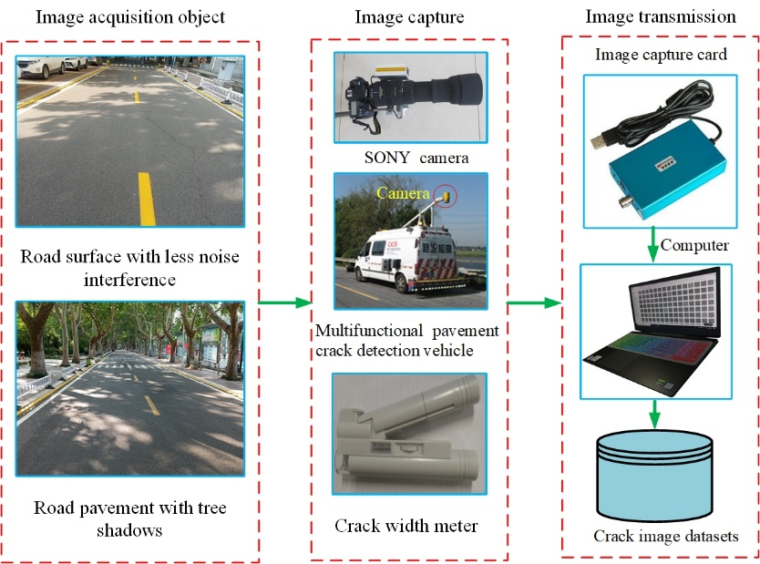

**Figure 3.** The crack image acquisition device

Then, the analog signal from the camera was converted into a digital signal by the A/D module on the image acquisition card. Finally, the processed digital signal was transmitted to the computer by the RS485 concentration line. According to the various needs of users, the digital image was specifically processed. The image files were saved in external memory. The acquisition of the image samples was finally completed, while the samples and materials were provided for the later creation of the crack datasets.

After performing the above operation, more than 2,000 pavement images with a resolution ofpixels were obtained. For evaluating the accuracy of the proposed method, 1500 crack 6width images were measured by a crack width meter.

2.2 Crack datasets generation

Due to the large size of the images we collected, and the number is relatively small. The insufficient number of crack images can easily lead to the problem of overfitting in the training process. Therefore, the data augmentation is implemented, including a clockwise rotation of 90◦ and 180◦, and horizontal flip. And then, we use the sliding window cropping method to increase the number of crack datasets. Besides, when cutting the image, we record the location of each crack in a table, so that we can restore the original location.

To achieve a good compromise between the amount of calculation and the accuracy of the test results[33], the network trained by the small image (pixels image block) can test any larger than the training image block. However, if using a smaller image than the one selected here, the network may capture any elongated features, such as scratches. Also, smaller images make it more difficult to mark images as defects or integrity, thus the original images were cut into 3 channels (RGB)pixels block to create crack datasets.



(a) (b) (c) (d)

**Figure 4.** Crack images that may be disregarded in detection: (a) Left edge crack; (b) Lower edge crack; (c) Right edge crack; (d) Top edge crack.

As shown in Figure 4, some clipped image blocks by ordinary sliding and cutting methods may keep cracks on the edge of the image. For this reason, the images of these edges are easily ignored in the detection for the following reasons. Firstly, when the images pass the ILGCHDN model, the input images become smaller. Meanwhile, the images with crack edges are less likely to be recognized than those with cracks in the middle of the images. Secondly, it is impossible to determine whether these crack features are true cracks or not. As a result, the error annotations of training datasets are caused. Thirdly, even if the images are classified by the training network, the generalization ability of such a training model is relatively poor due to difficulty in identifying crack features. Moreover, the accuracy is reduced when evaluating the model on the test sets.



**Figure 5.** The process diagram for cutting crack images using the overlapping sliding window technology

To solve the above problems, this paper improves the traditional image cropping technology and uses the overlapping sliding window to cut the images, as shown in Figure 5 [19]. The first sliding moves 128 pixels each time along the width of the crack image. When the second sliding is performed, 128 pixels are moved first in the image height direction, and then moves 128 pixels each time along the image width direction to cut. Therefore, each crack image in the cut image block is located in the central region of the image as much as possible. Repeat the above steps until all the images have been cropped.

**Table 1.** Asphalt crack image datasets

|  |  |  |  |  |  |  |  |
| --- | --- | --- | --- | --- | --- | --- | --- |
| Task | No. of images | Size(pixels) | Crack | Non-crack | Training sets | Validation sets | Test sets |
| Classification | 40000 |  | 20000 | 20000 | 24000 | 8000 | 8000 |
| Segmentation | 8000 |  | 8000 | 0 | 4800 | 1600 | 1600 |

As shown in Table 1, in this paper, 20,000 crack images and 20,000 non-crack images are randomly selected from the established crack datasets for the experimental analysis. The extracted images are divided into training sets, validation sets, and test sets according to the ratio of . Crack images are labeled by the deep learning annotation tool LabelMe.

* 1. ILGCHDN model

The proposed ILGCHDN model is a crack image classification model with good robustness. It combines the low-rank convolution kernel and the group convolution. Due to the characteristics of the low-rank convolution kernel and the group convolution, the model has no more parameters when expanding and deepening the network, so it can achieve better results. The model is described in detail below.

1. ILGCHDN architecture

As shown in Figure 6, the ILGCHDN model is composed of the convolution layer, the batch normalization layer, the activation layer, the global average pooling layer, and a softmax layer. The ILGCHDN model mainly designs eight modular convolution blocks. To remove redundancy and reduce weight parameters, we use low-rank convolution kernels. However, the too sparse convolution kernel will reduce the accuracy of the model, so each convolutional block uses the interleaved low-rank group convolution to form a dense convolution kernel[34]. A low-rank convolution kernel is a form of multiplying a large convolution kernel into several small convolution kernels. The group convolution is to group the input images, and then each group is convolved separately. The convolution kernel in the group convolution is only convolved with the input images of the same group. The group convolution can be seen as a structured sparse. It can reduce the total parameter amount of the convolution kernel. Since the low-rank convolution kernel and the group convolution are used in each convolution block. And this effective combination can’t increase the network parameters while widening and deepening the network, thereby achieving better results.



**Figure 6.** The ILGCHDN classification model structure diagram

After each convolution in the convolution block, the batch normalization processing is performed and activated by the nonlinear activation function ReLU, then enter the result into the next layer of the network. After the convolution is finished, to obtain the characteristic response between adjacent pixels, a global average pooling (GAP) layer is used to take the place of the fully connected layer and the dropout layer in the traditional convolutional neural network. The principle of the GAP is to use the feature map to directly represent the confidence map belonging to a certain category. For example, there are two classes in this paper, two feature maps are output at the end. The values in each feature map are added to calculate the average. These two averages are the corresponding probability or the confidence level, and then the two averages obtained are directly used as the probability of belonging to a certain class. The GAP can not only reduce the computational load of training and testing, but also improve the convergence speed of model training and testing. Meanwhile, it can prevent over-fitting phenomena caused by excessive parameter quantities. Furthermore, the last layer of the ILGCHDN model uses a softmax function to calculate the probability that the input image block belongs to each class, thereby classifying the crack and non-crack images.

The convolution process of the ILGCHDN model effectively combines the low-rank convolution with the group convolution. For this reason, this way not only can more crack features be extracted, but also redundancy can be eliminated, and more efficient calculations can be added. The convolution process is described in detail below.



**Figure 7.** The convolution block of the ILGCHDN model. The first group convolution is aconvolution, which widens the network. The second convolution is aspatial convolutions. The third group revolution is also aconvolution, which compresses the network structure to the original width.

As shown in Figure 7, this paper uses the convolution method of interleaved low-rank group convolution, where the rank means resolution. Each interleaved low-rank group convolution module includes two group convolution and a spatial convolution. The first group convolution in each convolution block of the ILGCHDN model divides the input channel into two groups (), and then convolves with aconvolution kernels on the two super-channels. Where each super-channel is a group of channels, due to , so there are two super-channels in the first group convolution. In this way, it can raise the dimension, make the network wider, and acquire more features of the crack. Next, the results of the two group convolutions are stitched together to get new input. The second convolution is a spatial convolution of the channel direction of a . Firstly, theconvolution kernel is divided into a multiplication of aand a low-rank convolution kernel, and then convoluted point by point. And this low-rank convolution method can improve the convergence efficiency of the model training. The third convolution is ainterleaved group convolution of , and the convolution order is exchanged on the two channels relative to the  group. This interleaved group convolution serves as a dimension reduction effect, and the network is reduced back to the initial width. The mathematical formula is as follows:

 (1)

Whereandare permutation matrices,re-groups the convolution results in disorder, andre-splices the convolution results together.  is the input matrix, is the output matrix, and corresponds to theconvolution of the channel direction, and are low-rank sparse matrices. The mathematical expressions of these two low-rank sparse matrices are as follows:

${\hat{W}}^{(0)}=\left[\begin{matrix}{\hat{w}}_{1,1}^{(1)} & 0 & 0 & 0 \\ 0 & {\hat{w}}_{1,2}^{(1)} & 0 & 0 \\ ⋮ & ⋮ & ⋱ & ⋮ \\ 0 & 0 & 0 & {\hat{w}}_{G_{int},K}^{{(G}_{1})}\end{matrix}\right]$， $W^{(2)}=\left[\begin{matrix}w_{1}^{(2)} & 0 & 0 & 0 \\ 0 & w_{2}^{(2)} & 0 & 0 \\ ⋮ & ⋮ & ⋱ & ⋮ \\ 0 & 0 & 0 & w_{G_{2}}^{(2)}\end{matrix}\right]$ (2)

Whereis a row vector containing  non-zero weights, corresponding to the convolution kernel of the  branch in the first group convolution,indicates the number of channels. For example, , which increases the number of channels.  corresponds to the convolution kernel of the  branch in the second group convolution, which decreases the channel width back to the initial width.

From the above analysis, the ILGCHDN model can not only reduce the model parameters by effectively combining the low-rank kernel and the group convolution, but also can obtain information from multiple paths in the input channel by interleaving convolution. Furthermore, it extracts crack features during the convolution process. More crack features can improve the accuracy of the crack classification.

B. ILGCHDN training

Given a crack image training set , which involvesimages, whererepresents the image patch and the relevant class label is. If, thenrepresents a positive sample. Otherwise,represents a negative sample. The probability calculation formula is as follows:

 (3)

Where  are inputs of the softmax layer. represents the weight, since the initial value ofin the training process is randomly assigned, there is usually a certain deviation between the predicted class and the actual class. In this section, the focal loss function is used to quantify the deviation of the classification.

 (4)

Whereis a scalar of 0 or 1, indicates the adjustment factor. The $γ$ plays the role of smoothing loss. Through continuous experiments, it is found that the result is optimal when $γ$ is 2. The  is the probability of prediction class. andrepresent large penalties for the misclassification.

To prevent the local minimum value during the training process, the ILGCHDN model training uses the mini-batch gradient descent (MBGD) method to iteratively solve the optimal parameters. This method can not only accelerate the convergence speed, but also improve the training accuracy. The initial parameters are ,and.The momentum parameter is 0.9, iterative 50 epoch. As shown in Figure 8 and Figure 9, the training precision is 99.13%, and the loss is 0.026, respectively, which achieved better training results.

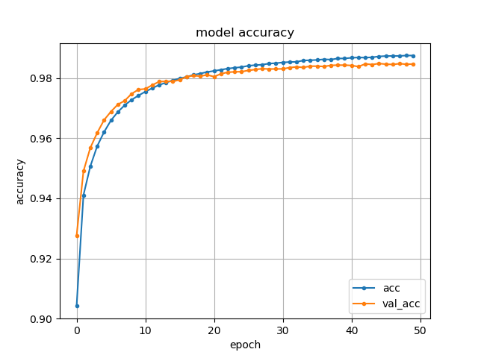 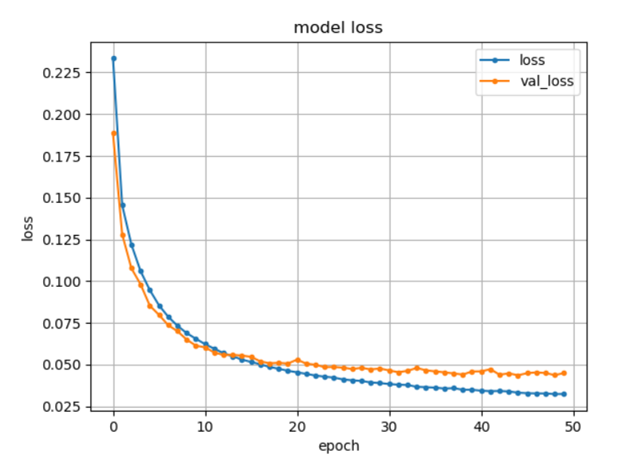

**Figure 8.** ILGCMDN model training accuracy **Figure 9.** ILGCMDN model training loss

* 1. Image binarization algorithm

Due to the topology of the crack image and the complexity of the background, the crack has different brightness at different positions of the image. Consequently, the pure SegNet network can cause information loss by the max-pooling operation in the down-sampling process. It is difficult to achieve good results between positioning accuracy and segmentation performance. To solve the above problem, the SegNet network and the dense condition random field algorithm are effectively combined, which successfully handles the information loss and positioning challenge problems.



**Figure 10.** A diagram of the SegNet-DCRF architecture

As shown in Figure 10, the SegNet contains an encoder network and a matching decoder network. Moreover, the entire network has no fully connected layers. The important part of SegNet is the decoder network, which includes a hierarchy of decoders, each decoding layer is related to a decoder. Especially, a decoder uses the transmission pool indices from its encoder to up-sample the input to generate a sparse feature map. Then the convolution with a trainable filter bank is used to densify the feature map. Finally, the final decoder output feature maps are provided to a softmax classifier for pixel-by-pixel classification. To get better crack segmentation results, a DCRF model is added after the SegNet to optimize the segmentation results.

1. SegNet model

The SegNet is devised to be a high-efficiency structure for pixel-by-pixel semantic segmentation[35]. As shown in Figure 11, the SegNet contains an encoder network and a matching decoder network. Furthermore, the decoder network is followed by a softmax layer for pixel-by-pixel segmentation. The 13 convolutional layers in the encoder network are composed of the first 13 convolutional layers in the VGG16 network [36]. Therefore, the training process can be initialized from the weights trained for large datasets classification[37]. It is also possible to desert fully connected layers to preserve higher resolution feature maps at the deepest encoder output. In the encoder network, the number of parameters can greatly decrease. Since each encoder layer has a matching decoder layer, the decoder network also has 13 layers. The final decoder output is input to the softmax layer to independently calculate the class probability for each pixel to achieve the coarse segmentation effect.



**Figure 11.** Encoder and decoder (SegNet) network

Due to the structure and special operations of the SegNet, the application of SegNet to low-level crack image processing has two major technical obstacles, which are the low feature resolution and the low local positioning accuracy. The decrease in feature resolution is mainly due to the down-sampling of the image. The max-pooling layer commonly used in the SegNet will extract the maximum feature value in a certain region. Therefore, other feature values ​​in the region will be discarded, which makes most of the detailed features in the image are not used. Meanwhile, only the most important features in the image can participate in the training and calculation of the subsequent part of the network. This is sufficient for the task of high-level image processing that requires abstract summary features. While for the low-level image processing, dense pixel-level features need to be expressed and extracted. The reduction in feature resolution will make the SegNet unable to take into account all pixels. The crack segmentation results have large errors. The main reason for the low local positioning accuracy is that the spatial translation invariance limits the spatial accuracy of the SegNet. For example, in the operation of the max-pooling layer, only a certain maximum value will be selected in the region. That is to say, the maximum value in the region is the representative value. As long as the spatial translation of the image is in the region, the representative value is the maximum value.

Because of the above problems, this paper adopts the method of connecting a dense condition random field after the SegNet to model the context. Therefore, the features of different levels can be combined more effectively, to achieve a good crack segmentation effect.

1. DCRF model

Although the SegNet network can complete the task of pavement crack detection, a lot of experiments show that the pure SegNet crack segmentation algorithm is not very good at the edge of the images. Besides, it is also difficult to eliminate noise interference for crack images with large noise interference, and the robustness is poor. In this paper, a DCRF model is added to the back end of the SegNet network to optimize crack segmentation results.

The CRF model is a probability map proposed by Lafferty et al. [38]. Traditional conditional random fields are used to smooth the noisy segmentation map. Typically, these models couple adjacent nodes to facilitate the assignment of the same markers to spatially close pixels. Qualitatively speaking, the main function of these short-range conditional random field is to eliminate false predictions, which builds on the local manual feature upper-level weak classifier. As shown in Figure 12, to overcome the limitation of the short-range conditional random field, the random field model is densely connected in the system. The DCRF is more efficient and can capture details of thin edge. For each pixel, there is a corresponding label for the category label. For this reason, each pixel is used as a node. Moreover, the relationship between the pixel and the pixel acts as an edge, which constitutes a dense condition random field. Additionally, we estimate the category label corresponding to the pixel by observing the variable.



**Figure 12.** Dense conditional random field

Letbe a factor graph of. If any valueofcan be assigned a factor according to , thenis a dense condition random field. Letbe a label random variable that can be valued from,  is a vector formed by random variable , and the number of pixels in the image is. The model can be expressed as an undirected graph model, where is the set of nodes in the graph, is the set of undirected edges between nodes. The DCRF model as shown below:

(5)

In equation (5),represents the energy function. is a partition function. The formula of the energy function is as follows:

 (6)

Where is a univariate energy function, which includes the shape, texture, position and color of the crack image.  is a pairwise energy function, which describes the relationship between each pixel and all other pixels.is a corresponding node, andis a distribution parameter obeyed byand.

In the crack image binarization algorithm, the univariate energy component is based on the characteristics of a single-pixel of the SegNet, which is the one-to-one relationship between pixels and the univariate energy. While the pairwise energy component is not only based on itself, but also eight pixels, four adjacent edges and four adjacent nodes. However, due to the complexity and the computational feasibility, not all eight adjacent pixels are modeled as pairs of energy components. In the paper, a joint model of four adjacent edge pixels is proposed to decrease the computational complexity and minimize the impact as little as possible. The univariate energy function is as follows:

 (7)

Whereis an indicator function of 0 or 1.  is theinput of the feature vector.is the parameter of the state function. Pairwise energy functions are defined as follows:

 (8)

Whereis the parameter of the conversion function . is the corresponding node.is the distribution parameter obeyed byand. Pairwise energy functions are the relationship between two pixels. The potential pairwise feature map is as follows:

 (9)

 represent the spatial relationship between adjacent top, bottom, left and right.

After determining the DCRF model, the model parametersneed to be estimated during the training phase. There are many methods for estimating the DCRF model parameters, such as the gradient rise algorithm[39,40]. In this study, the limit optimization method is used to estimate the model parameters[41]. After the parameters are determined, the probability that each pixel belongs to a certain semantic category can be obtained.



**Figure 13.** TheDCRF prediction process pseudo code

As shown in Figure 13, the prediction algorithm of the DCRF is the Viterbi algorithm. The optimization goal of the DCRF model is to search for the best solution. When the posterior probability of equation (5) is the maximum, we can determine the category label of each pixel.

1. SegNet-DCRF training

To train and optimize the proposed SegNet-DCRF model, a large number of optimization methods and hyperparameters need to be set in advance. The encoder and decoder weights were all initialized using the technique described in [42]. Hyperparameters are initialized with Xavier in the convolutional layer [43]. When the momentum stochastic gradient descent (SGD) method uses a well-designed random initialization method, the performance of the training model can be greatly improved. This section uses the SGD method to optimize model parameters and sets the initial learning rate as 0.1 and the momentum parameter as 0.9[44]. Also, the SegNet-DCRF model has trained 600 epochs with a batch size of 4 and using the cross-entropy loss as the objective function[45], as shown in equation (10).

 (10)

whereis the weight coefficient, represents the object value of thepixel, represents the predicted value of thepixel, andrepresents the total number of pixels in the entire image.

For crack images, the crack pixels account for a small part of the entire image. In this way, when classifying cracks and non-cracks at the pixel-level, the proportion of negative samples is very large, resulting in the training results used for prediction. Meanwhile, the network tends to judge the samples as negative samples. For this reason, the class imbalance problem will occur[46]. To solve this problem, the loss function is balanced on the basis of the true class by balancing the median frequency of the same class[47]. Specifically, we use median frequency balance, where the weight assigned to one class in the loss function is the ratio of the median class frequency calculated over the entire training set divided by the class frequency. The calculation process is as follows:

For the crack dataset, there are two classes of crack pixels and non-crack pixels. Let the number of pixel numbers in each class be. The median, corresponding to crack pixels and non-crack pixels, is calculated respectively. The total pixel number of the images denotes. Divide all  by  to get a new set of coefficients, and then take the reciprocal of these coefficients to get the weight coefficients of corresponding classes. Finally, the weight coefficientof the corresponding class can be expressed as formula (11).

 (11)

Specific analysis, for non-crack pixels, when divided by a number​, the order of size is the same as the previous sequence, still larger than the number of crack pixels. At this time, we take the reciprocal as the loss weight coefficient. This implies that non-crack pixels in the training set have a weight smaller than 1 and the weights of the crack pixels are the highest. Training with the median frequency balancing can generate more accurate models.

To compare the effects of different structural models, the following quantitative analysis indicators are used.

1. Global Accuracy (GA): The GA represents the percentage of pixels properly classified in datasets. And the calculation formula is below:

$GA=\frac{{correct}_{pixels}}{{total}_{pixels}}$ (12)

1. Mean Intersection Over Union (mIoU): The mIoU is a measurement index of the semantic segmentation. This index calculates the intersection and the union ratio of two sets. In the problem of crack segmentation, the two sets are the ground truth and the predicted segmentation[48]. For a given class, which translates to calculate the intersection over union (IoU) based on true positives (TP), false positives (FP), and false negatives (FN). Then the average of IoU is calculated to get mIoU[49].

 (13)

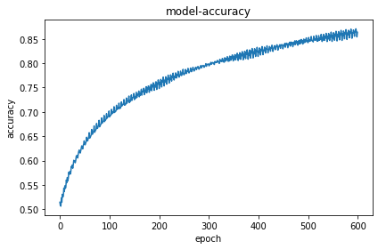 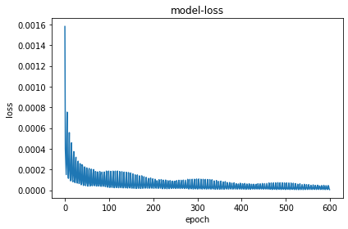

**Figure 14.** SegNet-DCRF model training accuracy **Figure 15.** SegNet-DCRF model training loss

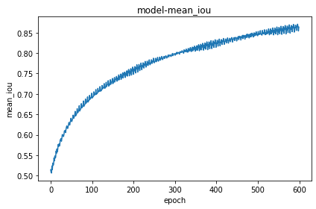

**Figure 16.** SegNet-DCRF model training mean_iou

8,000 crack images in the complex background are input into the SegNet-DCRF model for training. As shown in Figures 14, 15, and 16, the SegNet-DCRF model has iterated 600 epochs, and the final training accuracy is 0.89, the training loss is 0.0001, and the mIoU is 0.87.

* 1. Calculation of the mean crack width

For transverse cracks and longitudinal cracks, the crack width is important data for evaluating pavement disease. After crack images are binarized, cracks in the image show several connected domains. And in the image coordinate system, the coordinates of the crack pixelof each connected domain are counted to calculate the width of the crack.

Based on the characteristics of the image after binarization, this paper uses a central axis algorithm to obtain the mean width of the crack. The principle is shown in Figure 17, two continuous functions  and  are defined, and the area between these two functions represents the crack region. The midline equation between  and  is , and the longitudinal distance along the Y-axis is , is the inclination of the tangent of the curve  at the point. From the geometric relationship, . The width of the crack is expressed as:

 (14)



**Figure 17.** The schematic diagram of calculating crack width in image coordinate system

The specific process of the central axis algorithm proposed in this paper is as follows:

**Step 1：**The entire crack image is traversed by rows, then counts the number of crack pixel points in the row and the coordinates  of each pixel point.

**Step 2：**Calculate the mean valueof the coordinate of the crack pixel points in the row. The line connecting the average of the crack pixels in the entire image is the middle line of the crack. The inclination of the crack in the row is . Since the crack image is represented as a pixel block, which appears jagged edges in the length direction of the crack connected domain. To decrease the measurement error and smooth the connected domain, so it takes the adjacent five rows to calculate the inclination angle , and then  is averaged as the inclination angle of the point. The value is taken as the inclination of the point.

**Step 3:** The width of the crack is calculated according to the formula . Whererepresents the pixel resolution, that is, the crack width represented by each pixel.

* 1. Calculation of the web crack area

For web cracks, an important evaluation index is the area of the crack, and the health of the asphalt pavement is evaluated based on the damaged area. The area of the web crack is calculated by counting the number of crack pixels in the closed domain.



**Figure 18.** The schematic diagram of calculation of web crack area

As shown in Figure 18, for each row of pixels, the first and last pixel values are recorded as two points to establish the pixel distance, and the area is calculated by calculating the number of pixels contained in the outer closed contour.

1. **Experiment and analysis**

3.1 Experimental environment

All the algorithms in this paper were programmed by Python3. The models were implemented by using the classical deep learning-based Keras framework with backend in Tensorflow and trained on the Windows10 experimental platform, Intel® Quad-CoreTM i7-9750 CPU @ 3.6 GHz Processor, 16GB RAM and NVIDIA GeForce GTX 1080Ti 16GB GPU. Keras was born to carry out quick experimentation, and it is also able to quickly convert its ideas into results. For this reason, Keras can quickly and efficiently compare the visualization results of different crack detection algorithms.

To evaluate the performance of the crack classification and detection integrated system, 4,000 crack images, and 4,000 non-crack images were used to test the effect of the ILGCHDN model, and 1600 crack images were used to test the SegNet-DCRF model. Note that all of the test sets in this paper have never been used for training sets and validation sets.

* 1. Detection and classification model testing

To examine the performance of the proposed ILGCHDN model, which was tested on the dataset presented in section 2.2. The ILGCHDN algorithm was compared with Crack Forest, Gabor filter, SVM, CNN, NB-CNN, and MI-CNN crack classification algorithms. Different crack classification algorithms were quantified by using three indexes of precision, recall, and F1-score. These three indexes were calculated by TP (True Positives), TN (True Negatives), FP (False Positives), and FN (False Negatives), the specific definition is shown in Table 2.

**Table 2.** Some basic concepts in the evaluation indicators

|  |  |
| --- | --- |
| Symbol | Description |
| TP | TP refers to the number of cracks that are correctly classified as cracks. |
| TN | TN refers to the number of backgrounds that are correctly classified as backgrounds. |
| FP | FP refers to the number of backgrounds that are incorrectly identified as cracks. |
| FN | FN refers to the number of cracks that are incorrectly identified as the background. |

The calculation equations for precision, recall, and F1-score are as follows:

 (15)

 (16)

 (17)

During the test, the hyperparameter settings were guaranteed to be the same as the training process, such as the learning rate and momentum parameter, etc. Meanwhile, none of them were pre-trained. The quantitative test results are shown in Table 3.

**Table 3.** Performance comparison table of seven crack classification algorithms

|  |  |  |  |  |  |
| --- | --- | --- | --- | --- | --- |
| Algorithm | Evaluation index | | | | |
| Precision | Recall | F1-score | Model parameters | Images / Second |
| Crack Forest | 0.8315 | 0.8458 | 0.8385 | - | 13.7 |
| Gabor filter | 0.7819 | 0.7021 | 0.7398 | - | 12.1 |
| SVM | 0.8112 | 0.6732 | 0.7358 | - | 12.7 |
| CNN  NB-CNN  MI-CNN | 0.8697  0.9210  0.9420 | 0.9249  0.9321  0.9231 | 0.8965  0.9265  0.9324 | 356MB  365 MB  380MB | 16.0  17.2  19.1 |
| **ILGCHDN** | **0.9726** | **0.9802** | **0.9764** | **67.8 MB** | **34.0** |

As shown in Table 3, seven crack detection algorithms are used for comparative analysis on the crack datasets collected in this paper. Experimental results show that deep learning-based CNN, NB-CNN, and MI-CNN crack detection algorithms have better performance than traditional image processing algorithms. However, the NB-CNN integrates Naive Bayes, which makes the model more complicated and increases the model parameters while improving accuracy. The MI-CNN uses convolution kernels of different sizes to extract image features of different dimensions from different input ends, and then performs feature fusion. Although the detection accuracy is improved in this way, the model parameters and the amount of calculation is relatively increased. The ILGCHDN model adopts the convolution method of interleaved low-rank group convolution, which can play a sparse effect. Further, the global average pooling operation after the model convolution can eliminate redundancy and improve the model processing rate. As a result, the model parameters are less than CNN, NB-CNN, and MI-CNN. Also, the speed of crack image classification is measured by the number of images classified per second, that is, images/second. The ILGCHDN model processes 34 images per second, so the speed of processing images is faster and more efficient. All in all, the ILGCHDN algorithm can improve the detection speed while reducing the model parameters.

* 1. Crack binarization model testing

To verify the effect of the model, the SegNet-DCRF algorithm proposed in this paper is compared with the existing classical crack extraction algorithms FCN[23], U-Net[25], Pyramid scene parsing network(PSPNet)[17], DeepLabv3+[18], SegNet[29], and DeepCrack [30].

In this section, three groups of comparison experiments were set up. The first group was the comparison of the visualization results of wide cracks. And then, the second group was the comparison of the test results of thin cracks. Additionally, the third group was the comparison of complex cracks tests.

1. Experiment 1: Comparison of visualization results of wide crack images

To verify the best performance of the SegNet-DCRF model in crack segmentation, this experiment conducted comparisons in multiple wide cracks. Some representative experimental results are shown in Figure 19. The first column in the figure is the original image of the crack, some of which have noise interference such as manhole cover, parking line, plant interference, rough background, etc., which leads to the main challenge in crack detections. The second column is the label image marked by the LabelMe tool. Moreover, the following columns are the binary results of FCN, U-Net, PSPNet, DeepLabv3+, SegNet, DeepCrack, and SegNet-DCRF, respectively.

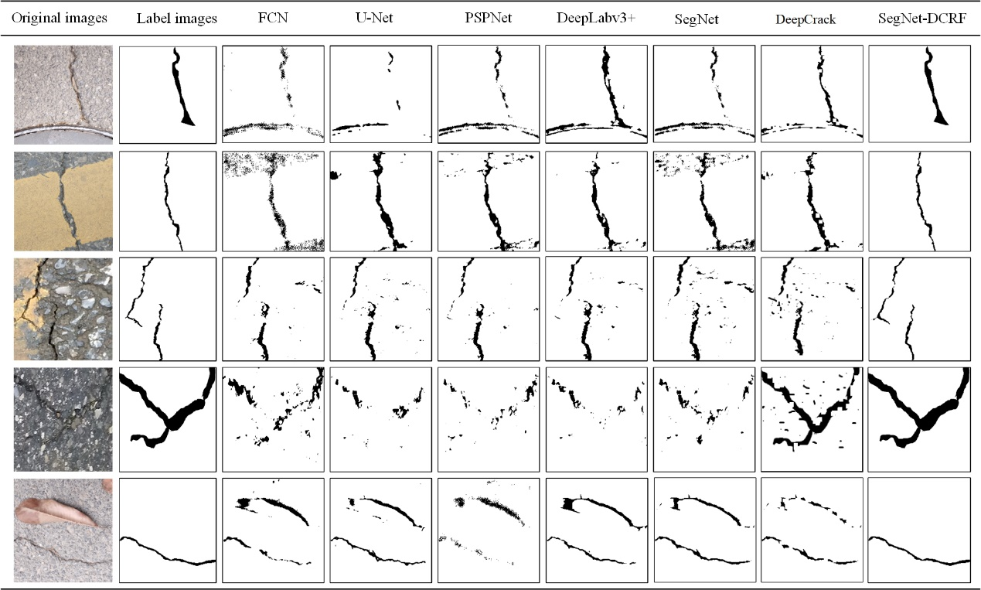

**Figure 19.** Binary effect images of various comparison algorithms for wide cracks

Figure 19 shows the results of five representative crack binarization visualizations, all methods can mark the crack region. However, FCN, U-Net, PSPNet, DeepLabv3+, DeepCrack, and SegNet can cause information loss, and can only roughly mark a crack region. Besides. When there are some noise interferences, these comparison algorithms exist some case of false detection. On the other hand, our SegNet-DCRF integrates the SegNet and the DCRF, which can further improve the accuracy of crack and robustness, effectively eliminate noise interference and achieves better crack segmentation results.

1. Experiment 2: Comparison of visualization results of thin crack images

In this experiment, to further compare the crack binarization effect and generalization ability of different algorithms, multiple thin cracks were analyzed experimentally. And the visualization results of the five representative crack images are shown in Figure 20.

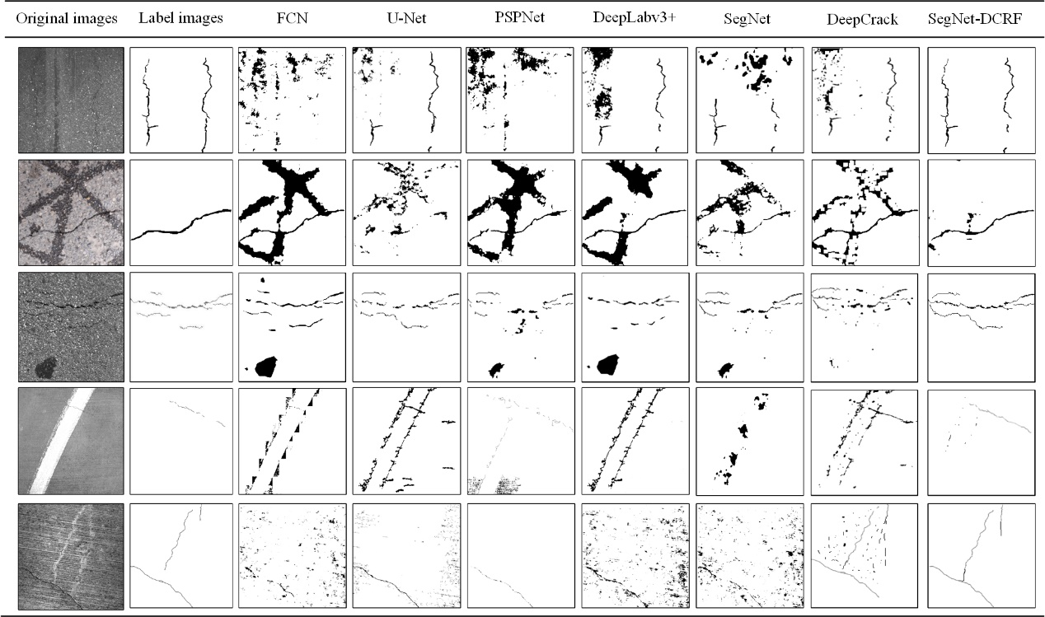

**Figure 20.** Binary effect images of various comparison algorithms for thin cracks

As shown in Figure 20, it can be seen that the segmentation results of pure SegNet have obvious defects in the case of crack edge and complex noise interference. The DeepCrack applied the skip structure to the SegNet network, which can extract more crack features. Compared with the SegNet, the DeepCrack has achieved better results, but the anti-interference ability is still not ideal. For FCN, U-Net, PSPNet, and DeepLabv3+ have poor anti-interference ability, when there are some noise interferences, which makes it easy to misjudge water stains, oil stains, parking line, etc. as crack regions. Meanwhile, these comparison methods cannot accurately extract crack features for some particularly thin crack images (especially edge crack images). However, in this work, the fusion of the DCRF model into the SegNet network can refine the segmentation results. The univariate energy function of the DCRF model includes the shape, texture, position and color of the image. The pairwise energy function of the DCRF describes the relationship between each pixel and all other pixels. The pairwise energy is established on all pixel pairs in the image to achieve great refinement and segmentation. Therefore, the SegNet-DCRF model can detect cracks with thinner edges, even exceeding the cracks marked in the real crack location. Especially for water stains and oil stains, in terms of appearance, compared with cracks, water stains and oil stains have more slender characteristics, and most of them are relatively wide shapes. Then our algorithm uses this principle to successfully eliminate the interference of water stains and oil stains.

1. Experiment 3: Comparison of visualization results of complex crack images

The crack segmentation in the complex background is a challenging problem. To verify the effect of the proposed crack segmentation algorithm, complex crack images are tested and compared. Figure 21 shows the five most representative images of complex cracks in the experimental results.

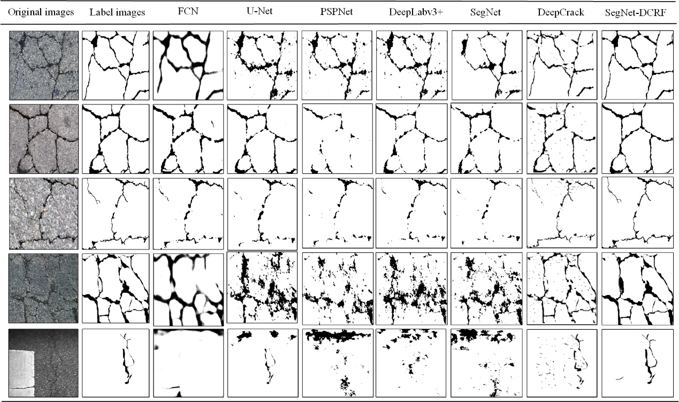

**Figure 21.** Binary effect images of various comparison algorithms for complex cracks

As shown in Figure 21, it can be found that the SegNet-DCRF still performs better. However, the FCN can almost detect the crack region, and the detection result is wider than the actual crack. U-Net, PSPNet, DeepLabv3+, SegNet can roughly mark the outline of the crack, but there is a loss of information, which makes it discontinuous for some thin cracks. At the same time, when the crack background is rough and the strength is uneven, the anti-interference ability is relatively poor, and the false detection will occur. The DeepCrack integrates low-level and high-level features in different scale convolution stages, which can improve the accuracy of the crack extraction. However, for the crack image with complex backgrounds, the detection effect is still not ideal. In this paper, a dense condition random field can be used to capture contextual information. Thus, the information loss caused by the max-pooling operation in the down-sampling process of the SegNet network is eliminated. Through an effective fusion of the SegNet and the DCRF, deep crack features can be captured, the basic spatial structure and position information in the crack image are considered. As a result, it has a better effect on eliminating the noise interference and a more refined effect on detecting image edges.

**Table 4.** Performance comparison table of various crack binarization algorithms

|  |  |  |  |  |  |  |  |  |
| --- | --- | --- | --- | --- | --- | --- | --- | --- |
| Algorithm | Frames per second (FPS) | Model parameters | Wide cracks | | Thin cracks | | Complex cracks | |
| GA | mIoU | GA | mIoU | GA | mIoU |
| FCN | 19.50 | 280.3M | 0.78 | 0.76 | 0.74 | 0.71 | 0.70 | 0.69 |
| SegNet | 28.12 | 29.5M | 0.80 | 0.79 | 0.78 | 0.77 | 0.75 | 0.73 |
| U-Net | 24.54 | 62.4M | 0.81 | 0.80 | 0.80 | 0.79 | 0.76 | 0.71 |
| PSPNet | 31.07 | 250.8M | 0.83 | 0.75 | 0.79 | 0.75 | 0.72 | 0.68 |
| DeepLabv3+ | 35.69 | 262.1M | 0.84 | 0.81 | 0.82 | 0.80 | 0.78 | 0.72 |
| DeepCrack | 24.10 | 58.5M | 0.85 | 0.83 | 0.84 | 0.82 | 0.81 | 0.80 |
| **SegNet-DCRF** | **42.10** | **32.2M** | **0.87** | **0.86** | **0.86** | **0.85** | **0.84** | **0.83** |

The above-mentioned different crack binarization algorithms are visually displayed. To better compare the experimental results, as shown in Table 4, the evaluation indexes in various environments are quantitatively listed. The mIoU of the SegNet-DCRF model is 0.86, 0.85, and 0.83 under the condition of wide cracks, thin cracks and complex cracks, respectively. Meanwhile, the speed of image segmentation is measured by frames per second (FPS), and the SegNet-DCRF processing rate is 42.10 FPS. Meanwhile, except for the SegNet, the model parameters are much smaller than other comparison algorithms. It can be seen from the table that the SegNet-DCRF model has higher evaluation indexes than the other six algorithms in the above cases.

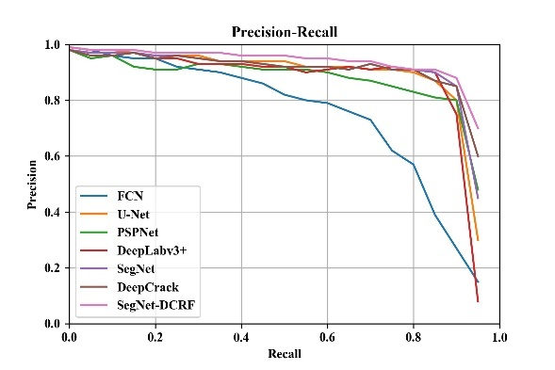 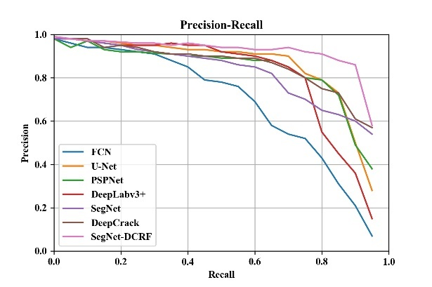

(a) (b)

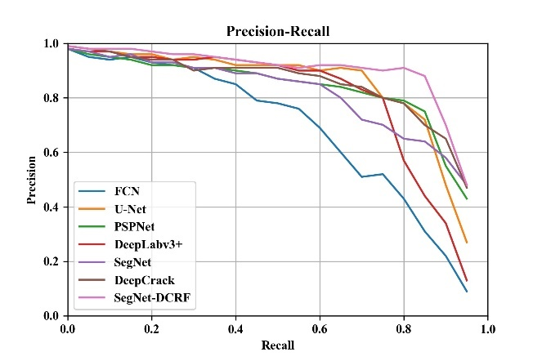

(c)

**Figure 22.** Precision-Recall curves on three group experiments. (a) wide cracks, (b) thin cracks, (c) complex cracks

Also, to further demonstrate the performance of different algorithms, existing research shows that the precision and recall (P-R) curve is more informative than the ROC-curve when evaluating binary classifiers on imbalanced datasets[50]. Therefore, we plotted the PR-curve based on the precision and recall of various comparison algorithms on wide cracks, thin cracks, and complex cracks. As shown in Figure 22, the SegNet-DCRF is the highest among all compared methods, which shows that our algorithm has a better crack segmentation effect and generalization ability.

Through the above three groups of comparative experiments, after the pixel-level feature extraction of crack images by the SegNet network, the condition random field in the probability map model acts as a structure prediction. Meanwhile, the condition random field is extended to the dense condition random field. As a result, the segmentation result of the crack image is refined, more features of the crack can be obtained more accurately.

In summary, compared with FCN, U-Net, PSPNet, DeepLabv3+, DeepCrack, and SegNet, the SegNet-DCRF has a better detection effect and less noise interference. At the same time, highlights better superiority for particularly thin cracks and edge cracks.

3.4 Calculate the mean width of the crack

In each crack image after binarization, each pointrepresents one pixel,  represents the crack pixel,  represents the background pixel. By traversing each row in the image, the number of pixels in each row of crack images is counted. Next, the mean width of the crack is calculated by the central axis algorithm.

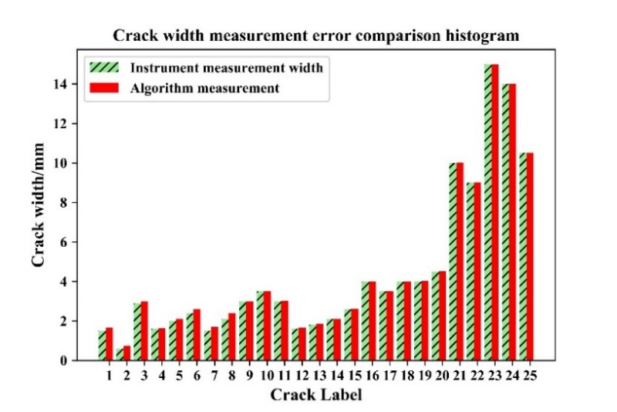

**Figure 23.** Thecrack mean width measurement error comparison bar chart

In this paper, the crack width measurement experiment uses multiple cracks after binarization to experiment. Figure 23 shows experimental measurements of 25 representative cracks. According to the artificial measurement value of crack width and the results of the algorithm, a bar chart can be drawn. When the crack width is less than 3 mm, the measurement error is a bit large. When the crack width is greater than 3 mm, the error is very small, the relative error is less than 0.02. Especially for wider cracks, the measurement error is close to 0. Also, it can be seen from Figure 23 that the crack width of the central axis algorithm is larger than the direct observation method. The crack width using the central axis algorithm has a certain continuity. Meanwhile, the mean crack width value is taken as the result. While the manual test result has a certain discreteness, so it is difficult to accurately detect the mean width of a crack. Moreover, the measured value of the crack width is measured manually by the crack width meter. Due to the accuracy of the instrument and the error of the human eye reading, the crack comparison result has a certain error.

* 1. Calculation and analysis of the web crack area

For web cracks, an important measure is to calculate the area of cracks. The size of the web cracks is used to evaluate the damage level of the asphalt pavement and provide technical support for highway maintenance. This paper first scans the web crack image from left to right, and then from top to bottom. In this way, we can find the outer contour of the web crack, and count the number of pixels between the first point and the last point in each line. Next, we statistically calculate the number of pixels surrounded by the closed region. Finally, we use the  of the camera calibration parameters to multiply the area represented by each pixel to obtain the actual area of the web crack.



**Figure 24.** Calculation of web crack parameters and evaluation of damage levels

As shown in Figure 24, the web crack area is calculated, and the damage level of the asphalt pavement is evaluated based on the crack area. This can make a comprehensive prediction of the health of the asphalt pavement.

* 1. Software interface of asphalt pavement detection system

To further demonstrate various information on crack detection, a mixed programming technology is used to improve working efficiency. Wherein the IDE of the Microsoft Visual Studio 2019 is utilized to integrate the main interface of the software. To raise the development efficiency, Python 3 to fulfill the image-processing steps. As for the SegNet-DCRF model training and verification, Python with the Tensorflow frame is implemented on the 1080Ti GPU equipped with the CUDA framework.



**Figure 25.** Thesoftware interface of the asphalt pavement detection system

The software interface is demonstrated in Figure 25. With this software, engineers can easily record pavement data for the crack detection which includes engineer’s information, collecting data and time, pavement master data, etc. At the same time, the distance infrared and angle sensors on the multi-functional road detection vehicle simultaneously collect distance and angle information.

1. **Summary and conclusion**

This paper develops an automatic recognition and analysis system of asphalt pavement cracks under the complex environment, which integrates crack image classification, crack image binarization processing, crack mean width calculation, and calculation of web crack area. The main work and conclusions of this paper are as follows:

(1) An improved overlapping sliding window technique is used to cut the collected datasets with a size ofpixels into image blocks of  pixels to establish a crack dataset.

(2) A pavement crack classification algorithm based on the interlaced low-rank group convolution hybrid deep network is proposed to classify crack and non-crack images. By iteratively optimize parameters of the ILGCHDN model on training sets and validation sets, a crack classifier with better robustness is obtained. The crack classification accuracy is 0.9726 on the test sets, and 34 images are processed per second atpixels, which are higher than Crack Forest, Gabor filtering, SVM, CNN, NB-CNN, and MI-CNN.

(3) The SegNet-DCRF model is proposed for crack image binarization, which makes full use of the recognition ability of the SegNet and the positioning ability of the DCRF. To verify the effect of the model on test sets, the test results were compared on wide cracks, thin cracks, and complex cracks, respectively. The mIoU of SegNet-DCRF is 0.86, 0.85, and 0.83, respectively. Besides, the SegNet-DCRF model processes in real-time (42.10 FPS) images atpixels, which are higher than FCN, U-Net, PSPNet, DeepLabv3+, SegNet, and DeepCrack*.*

(4) This paper uses a central axis algorithm to calculate the mean width of cracks. When the crack width greater than 3 mm, the relative error is less than 0.02. At the same time, the area of web cracks is calculated, which can comprehensively evaluate the crack grade.

(5) To further display the experimental results, a software interface is developed to display various information on the crack detection.

In summary, the images classified by the ILGCHDN model in this paper immediately input to the SegNet-DCRF for crack segmentation, so the entire system takes about 0.05s to process an image, which can meet real-time requirements and engineering design requirements. Subsequent research will continue to improve the crack image cropping technique, the Faster R-CNN based method using flexible bounding boxes will be used to cut the crack images, and get more effective crack datasets. And then, we will develop an efficient crack recognition and analysis platform that can integrate various sub-methods of this paper to achieve better crack detection results. Besides, inspired by the literatures[51,52], follow-up research will also attempt to combine crack detection with automatic driving to open up an efficient crack detection system.

**Declaration of conflicting interests**

All authors declare that there is no conflict of interest in this paper.

**Acknowledgment**

The research is jointly supported by the Key Research and Development Program of Shaanxi (2020ZDLGY09-03), the Key Research and Development Program of Guangxi (GK-AB20159032), the Science and Technology Bureau of Xi’an project (2020KJRC0130), and the Open Fund of the Inner Mongolia Transportation Development Research Center (2019KFJJ-006).

**References**

[1] Y. Fei, K.C.P. Wang, A. Zhang, C. Chen, J.Q. Li, Y. Liu, G. Yang, B. Li, Pixel-Level Cracking Detection on 3D Asphalt Pavement Images Through Deep-Learning- Based CrackNet-V, IEEE Transactions on Intelligent Transportation Systems, 21 (2020) 273-284.

[2] H.-N. Nguyen, T.-Y. Kam, P.-Y. Cheng, An automatic approach for accurate edge detection of concrete crack utilizing 2D geometric features of crack, Journal of Signal Processing Systems, 77 (2014) 221-240.

[3] I. Abdel-Qader, O. Abudayyeh, M.E. Kelly, Analysis of edge-detection techniques for crack identification in bridges, Journal of Computing in Civil Engineering, 17 (2003) 255-263.

[4] Z. Yiyang, The design of glass crack detection system based on image preprocessing technology, 2014 IEEE 7th Joint International Information Technology and Artificial Intelligence Conference, IEEE, 2014, pp. 39-42.

[5] S. Choi, K. Kim, J. Lee, S.H. Park, H.-J. Lee, J. Yoon, Image processing algorithm for real-time crack inspection in hole expansion test, International Journal of Precision Engineering and Manufacturing, 20 (2019) 1139-1148.

[6] Y. Cha, J.G. Chen, O. Buyukozturk, Output-only computer vision based damage detection using phase-based optical flow and unscented Kalman filters, Engineering Structures, 132 (2017) 300-313.

[7] L. Zhang, F. Yang, Y.D. Zhang, Y.J. Zhu, Road crack detection using deep convolutional neural network, 2016 IEEE international conference on image processing (ICIP), IEEE, 2016, pp. 3708-3712.

[8] N. Hoang, Q. Nguyen, A novel method for asphalt pavement crack classification based on image processing and machine learning, Engineering With Computers, 35 (2019) 487-498.

[9] M. Salman, S. Mathavan, K. Kamal, M. Rahman, Pavement crack detection using the Gabor filter, 16th international IEEE conference on intelligent transportation systems (ITSC 2013), IEEE, 2013, pp. 2039-2044.

[10] Q. Zou, Y. Cao, Q. Li, Q. Mao, S. Wang, CrackTree: Automatic crack detection from pavement images, Pattern Recognition Letters, 33 (2012) 227-238.

[11] H. Oliveira, P.L. Correia, Automatic Road Crack Detection and Characterization, IEEE Transactions on Intelligent Transportation Systems, 14 (2013) 155-168.

[12] R. Amhaz, S. Chambon, J. Idier, V. Baltazart, Automatic Crack Detection on Two-Dimensional Pavement Images: An Algorithm Based on Minimal Path Selection, IEEE Transactions on Intelligent Transportation Systems 17 (10) (2016) 2718-2729.

[13] A. Krizhevsky, I. Sutskever, G.E. Hinton, Imagenet classification with deep convolutional neural networks, Advances in neural information processing systems, 2012, pp. 1097-1105.

[14] O. Sudakov, E. Burnaev, D. Koroteev, Driving digital rock towards machine learning: Predicting permeability with gradient boosting and deep neural networks, Computers & Geosciences 127 (2019) 91-98.

[15] R. Girshick, Fast R-CNN, Proceedings of the IEEE international conference on computer vision, 2015, pp. 1440-1448.

[16] T.-Y. Lin, P. Dollár, R. Girshick, K. He, B. Hariharan, S. Belongie, Feature pyramid networks for object detection, Proceedings of the IEEE conference on computer vision and pattern recognition, 2017, pp. 2117-2125.

[17] H. Zhao, J. Shi, X. Qi, X. Wang, J. Jia, Pyramid Scene Parsing Network, computer vision and pattern recognition, 2017, pp. 6230-6239.

[18] L. Chen, G. Papandreou, F. Schroff, H. Adam, Rethinking Atrous Convolution for Semantic Image Segmentation, arXiv: Computer Vision and Pattern Recognition (2017).

[19] Y. Cha, W. Choi, O. Buyukozturk, Deep Learning-Based Crack Damage Detection Using Convolutional Neural Networks, Computer-Aided Civil and Infrastructure Engineering 32 (5) (2017) 361-378.

[20] Y. Cha, W. Choi, G. Suh, S. Mahmoudkhani, O. Buyukozturk, Autonomous Structural Visual Inspection Using Region‐Based Deep Learning for Detecting Multiple Damage Types, Computer-Aided Civil and Infrastructure Engineering 33 (9) (2018) 731-747.

[21] F. Chen, M.R. Jahanshahi, NB-CNN: Deep Learning-Based Crack Detection Using Convolutional Neural Network and Naïve Bayes Data Fusion, IEEE Transactions on Industrial Electronics 65 (5) (2018) 4392-4400.

[22] W. Zhao, C. Hua, D. Wang, D. Dong, Fault Diagnosis of Shaft Misalignment and Crack in Rotor System Based on MI-CNN, Proceedings of the 13th International Conference on Damage Assessment of Structures, Springer, 2020, pp. 529-540.

[23] X. Yang, H. Li, Y. Yu, X. Luo, T. Huang, X. Yang, Automatic Pixel‐Level Crack Detection and Measurement Using Fully Convolutional Network, Computer-Aided Civil and Infrastructure Engineering 33 (12) (2018) 1090-1109.

[24] Z. Liu, Y. Cao, Y. Wang, W. Wang, Computer vision-based concrete crack detection using U-net fully convolutional networks, Automation in Construction 104 (2019) 129-139.

[25] Z. Fan, C. Li, Y. Chen, J. Wei, G. Loprencipe, X. Chen, P. Di Mascio, Automatic Crack Detection on Road Pavements Using Encoder-Decoder Architecture, Materials, 13 (2020) 2960.

[26] F. Ni, J. Zhang, Z. Chen, Pixel-level crack delineation in images with convolutional feature fusion, Structural Control & Health Monitoring 26 (1) (2019).

[27] S. Bang, S. Park, H. Kim, H. Kim, Encoder–decoder network for pixel‐level road crack detection in black‐box images, Computer-Aided Civil and Infrastructure Engineering 34 (8) (2019) 713-727.

[28] X. Zhang, D. Rajan, B.A. Story, Concrete crack detection using context‐aware deep semantic segmentation network, Computer-Aided Civil and Infrastructure Engineering 34 (11) (2019) 951-971.

[29] V. Badrinarayanan, A. Kendall, R. Cipolla, SegNet: A Deep Convolutional Encoder-Decoder Architecture for Image Segmentation, IEEE transactions on pattern analysis and machine intelligence 39 (12) (2017) 2481-2495.

[30] Q. Zou, Z. Zhang, Q. Li, X. Qi, Q. Wang, S. Wang, DeepCrack: Learning Hierarchical Convolutional Features for Crack Detection, IEEE Transactions on Image Processing 28 (3) (2019) 1498-1512.

[31] F. Yang, L. Zhang, S.J. Yu, D. Prokhorov, X. Mei, H.B. Ling, Feature Pyramid and Hierarchical Boosting Network for Pavement Crack Detection, IEEE Transactions on Intelligent Transportation Systems 21 (4) (2020) 1525-1535.

[32] Q.P. Mei, M. Gul, M.R. Azim, Densely connected deep neural network considering connectivity of pixels for automatic crack detection, Automation in Construction 110 (2020) 13.

[33] D.C. Cireşan, A. Giusti, L.M. Gambardella, J. Schmidhuber, Mitosis detection in breast cancer histology images with deep neural networks, International conference on medical image computing and computer-assisted intervention, Springer, 2013, pp. 411-418.

[34] K. Sun, M. Li, D. Liu, J. Wang, IGCV3: Interleaved Low-Rank Group Convolutions for Efficient Deep Neural Networks, arXiv: Computer Vision and Pattern Recognition (2018).

[35] H. Guo, G. Wei, J. An, Dark Spot Detection in SAR Images of Oil Spill Using Segnet, Applied Sciences 8 (12) (2018) 2670.

[36] K. Simonyan, A. Zisserman, Very deep convolutional networks for large-scale image recognition, arXiv: Computer Vision and Pattern Recognition (2014).

[37] O. Russakovsky, J. Deng, H. Su, J. Krause, S. Satheesh, S. Ma, Z. Huang, A. Karpathy, A. Khosla, M.S. Bernstein, ImageNet Large Scale Visual Recognition Challenge, International Journal of Computer Vision 115 (3) (2015) 211-252.

[38] J. Lafferty, A. Mccallum, F. Pereira, Conditional Random Fields: Probabilistic Models for Segmenting and Labeling Sequence Data, international conference on machine learning, 2001, pp. 282-289.

[39] J. Domke, Learning Graphical Model Parameters with Approximate Marginal Inference, IEEE transactions on pattern analysis and machine intelligence 35 (10) (2013) 2454-2467.

[40] L. Chen, G. Papandreou, I. Kokkinos, K. Murphy, A.L. Yuille, Semantic Image Segmentation with Deep Convolutional Nets and Fully Connected CRFs, arXiv: Computer Vision and Pattern Recognition (2014).

[41] B. Krishnapuram, L. Carin, M.A.T. Figueiredo, A.J. Hartemink, Sparse multinomial logistic regression: fast algorithms and generalization bounds, IEEE transactions on pattern analysis and machine intelligence 27 (6) (2005) 957-968.

[42] K. He, X. Zhang, S. Ren, J. Sun, Delving Deep into Rectifiers: Surpassing Human-Level Performance on ImageNet Classification, 2015 IEEE International Conference on Computer Vision (ICCV), 2016.

[43] X. Glorot, Y. Bengio, Understanding the difficulty of training deep feedforward neural networks, Proceedings of the thirteenth international conference on artificial intelligence and statistics, 2010, pp. 249-256.

[44] V. Badrinarayanan, A. Handa, R. Cipolla, SegNet: A Deep Convolutional Encoder-Decoder Architecture for Robust Semantic Pixel-Wise Labelling, Computer Vision and Pattern Recognition, 2015.

[45] J. Long, E. Shelhamer, T. Darrell, Fully convolutional networks for semantic segmentation, Proceedings of the IEEE conference on computer vision and pattern recognition, 2015, pp. 3431-3440.

[46] A. Ji, X. Xue, Y. Wang, X. Luo, W. Xue, An integrated approach to automatic pixel-level crack detection and quantification of asphalt pavement, Automation in Construction 114 (2020).

[47] L.A.D.O. Junior, H.R. Medeiros, D. Macedo, C. Zanchettin, A.L.I. Oliveira, T.B. Ludermir, SegNetRes-CRF: A Deep Convolutional Encoder-Decoder Architecture for Semantic Image Segmentation, international joint conference on neural network, 2018, pp. 1-6.

[48] M. Everingham, S.M. Eslami, L. Van Gool, C.K.I. Williams, J. Winn, A. Zisserman, The Pascal Visual Object Classes Challenge: A Retrospective, International Journal of Computer Vision 111 (1) (2015) 98-136.

[49] Z. Zhang, X. Wang, Q. Xin, A New Performance Metric for Construction of Robust and Efficient Wireless Backbone Network, IEEE Transactions on Computers 61 (10) (2012) 1495-1506.

[50] T. Saito, M. Rehmsmeier, The Precision-Recall Plot Is More Informative than the ROC Plot When Evaluating Binary Classifiers on Imbalanced Datasets, PLoS One 10 (3) (2015).

[51] M. Martinez-Garcia, Y. Zhang, T. Gordon, Memory Pattern Identification for Feedback Tracking Control in Human-Machine Systems, SAGE Human Factors 2020.

[52] M. Martinez-Garcia, T. Gordon, A new model of human steering using far-point error perception and multiplicative control, 2018 IEEE International Conference on Systems, Man, and Cybernetics (SMC), IEEE, 2018, pp. 1245-1250.